For the Practical Test; see if you can answer these questions that you will be coming across in Driving Lessons for your General Driving: -
Cockpit Drill and Instruments and controls
What controls do you adjust and operate when you get into the car to put everything in the right place for you as the driver before you think about driving off?
D
S
S
S
M

Working from right to left, name the pedals: -

A
B
C (For manual only)

Why are there two sets of numbers on the speed dial?

For Automatic only what is? : -

P
D
N
R

When would you generally use P and when would you general use N?

For Manual only, on flat ground, at what speed would you go into the following gears?: -

1st
2nd
3rd
4th
5th

Is it more fuel efficient to be in a higher gear or lower gear?

Moving off and stopping
What does POM stand for?

P
O
M

When do you use this routine?

Why do you use this routine?

What does MSM stand for?

M
S
M

When do you use this routine?

Why do you use this routine?

Who is the most vulnerable road user?
- Pedestrians
- Motorbikes
- Cyclists

Where must you check last when pulling off from the left for the most vulnerable road user?

Which mirrors in the car have the right distance, and which have the wrong?

Why do some mirrors have the wrong distance?

Junctions

What is your priority when you are emerging at give way line or a stop line?

- First you can just go
- Second
- Last

If a car on the major road signals that he is turning left, and goes straight and you go, who is legally at fault for the accident?

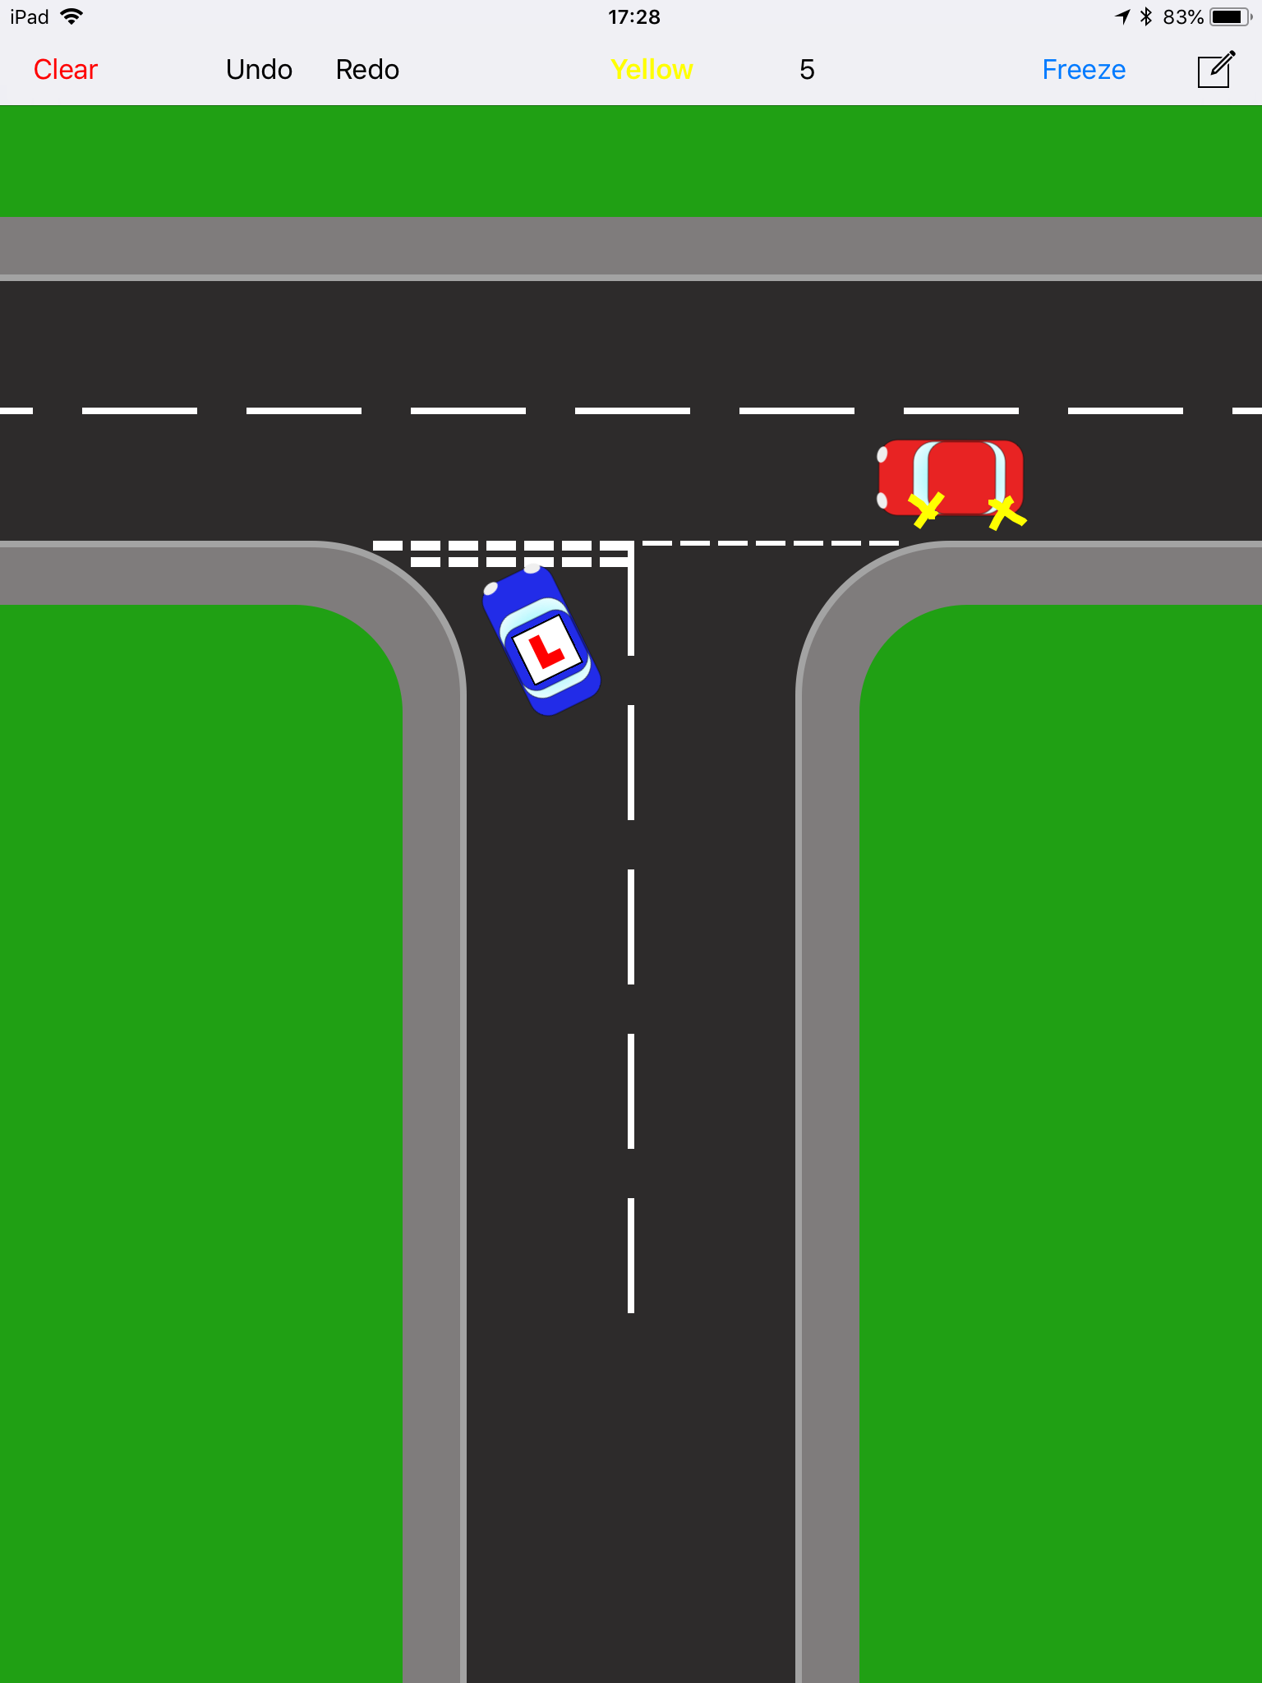

If it is not your priority, but you are not in anyone else’s way, can you go?
- Yes
- No

What does MSPSL stand for?

M
S
P
S
L

At a Give Way line you must;
- Look when over the line
- Look once each way before the line
- Look at least twice each way before the line

At a Give way line / an Emerging, if you cannot see around parked cars, what should you do?

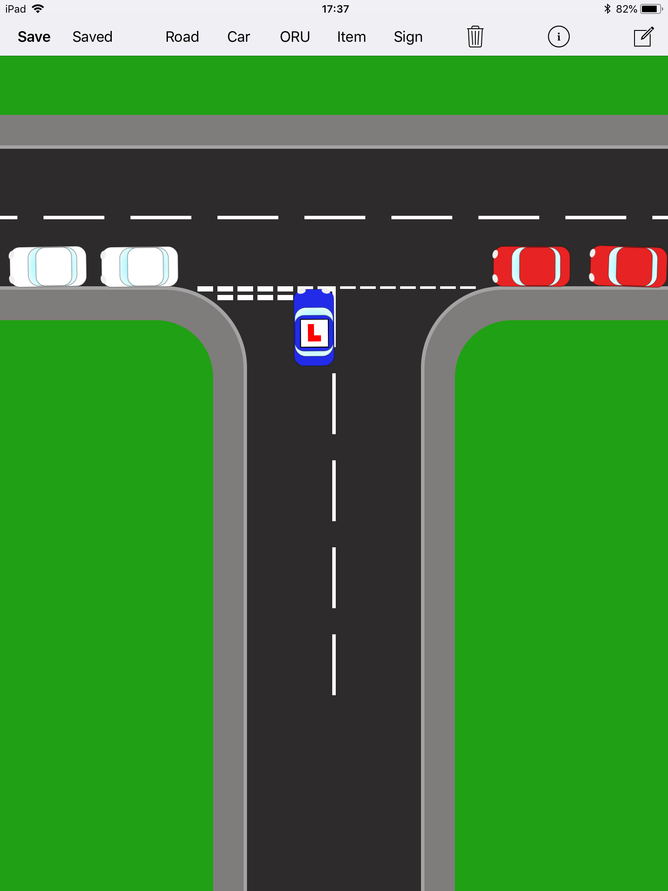

If you are approaching a T Junction and can see a Lorry wishes to turn into the road should you

- Wait at the give way line
- Wait further back
- Speed up
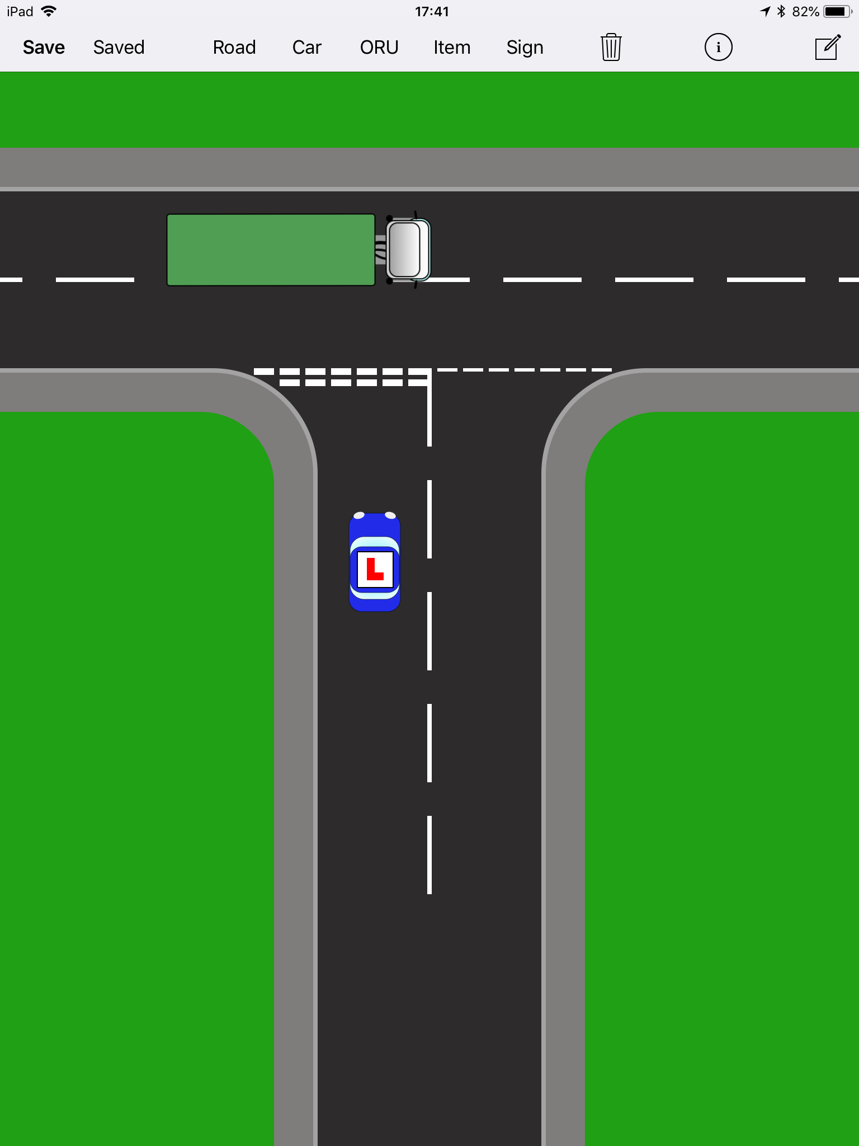

What could happen if you do not?

If you are turning left, who has the priority from a major road onto a minor road; what is your priority?

- First
- Second
- Last

If you are turning right, what is your priority?

- First
- Second
- Last

If you are approaching a right turn wanting to turn right, but your way is blocked, what should you do?

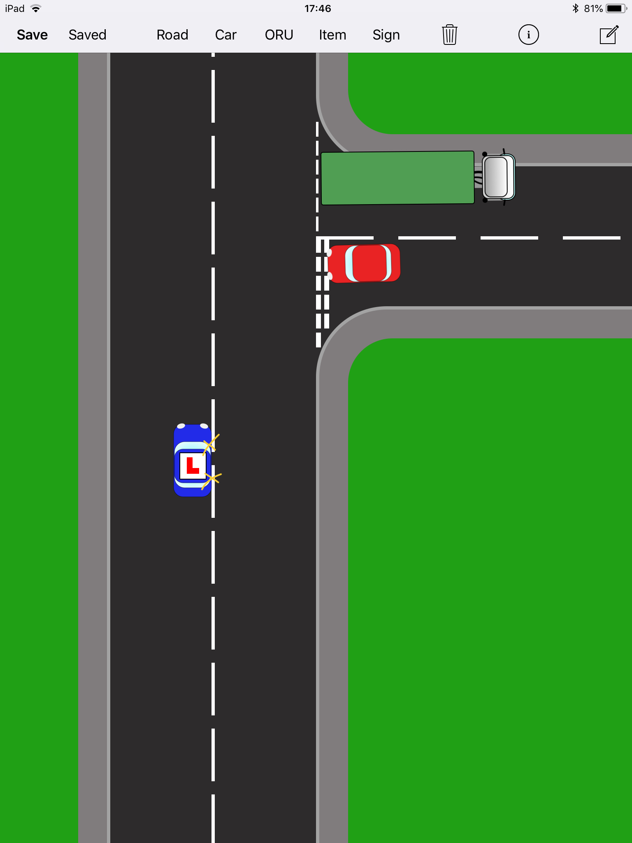

Do you always take your priority?

If you gave up your priority at high speed who would it affect?

Why are manners not in the High Way Code book?

- The instructor and examiner will do them for me
- The rule book says so
- Less experienced drivers trying to say thank you can easily loose position, and it is more important to stay safe and accident free.

What is the difference between a stop and a give way line?

Use of speed
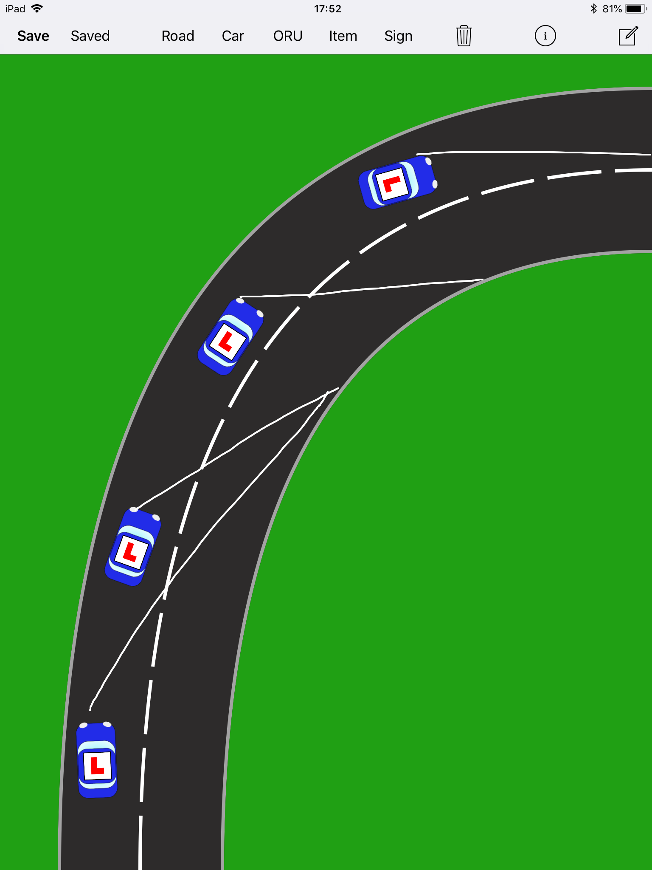

Do you always have to drive to the maximum speed limit?
- Yes
- No

Upon approach to a bend do you speed up or down
On the bend itself do you speed up or down?

Why is driving too slowly dangerous?

Why is driving too fast dangerous?

Mirrors

The Highway codes states that Mirrors are checked before any change of Direction or Speed.

When stationery, at traffic lights or in a traffic jam which smaller road users could be weaving in and out of traffic?

Where should you check before you go?

What would happen if we checked all 3 three mirrors at this junction turning right every time there was a gap?

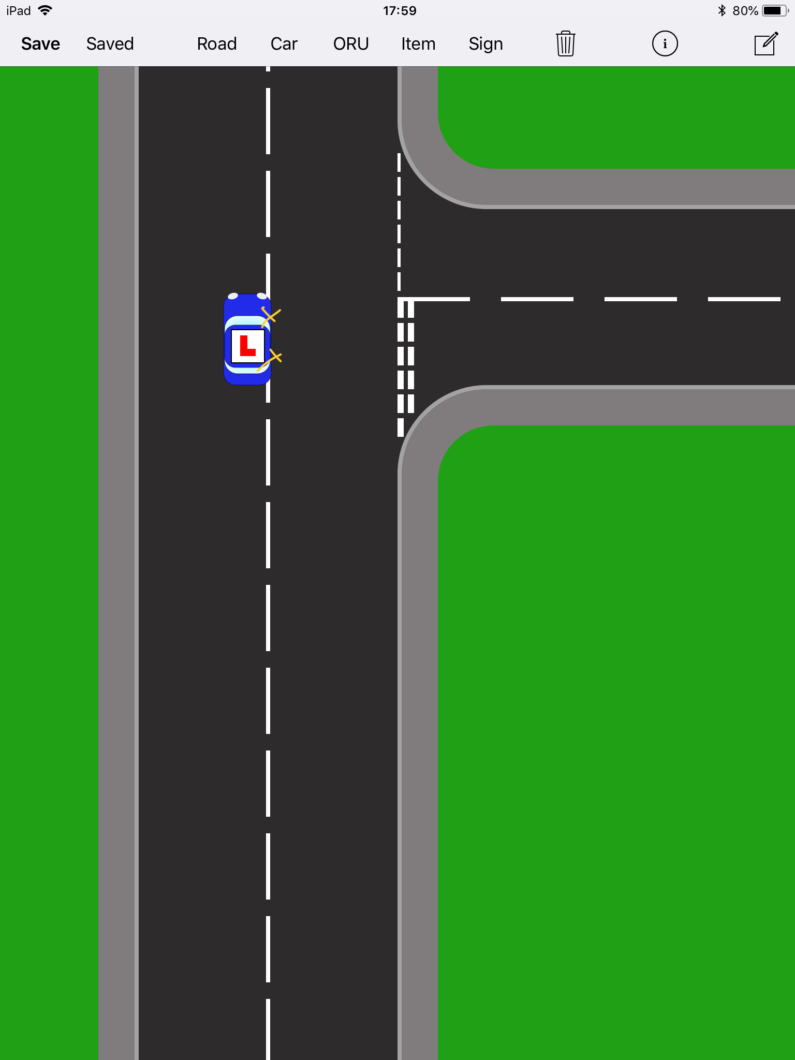

What do we do about that?

Why new road, new mirrors?

What Mirrors would you check when moving around a parked car?

What Mirror should you check before you slow unless you are in an emergency situation?

Why?

Meeting Vehicles

If the parked car is on your side which car goes first?

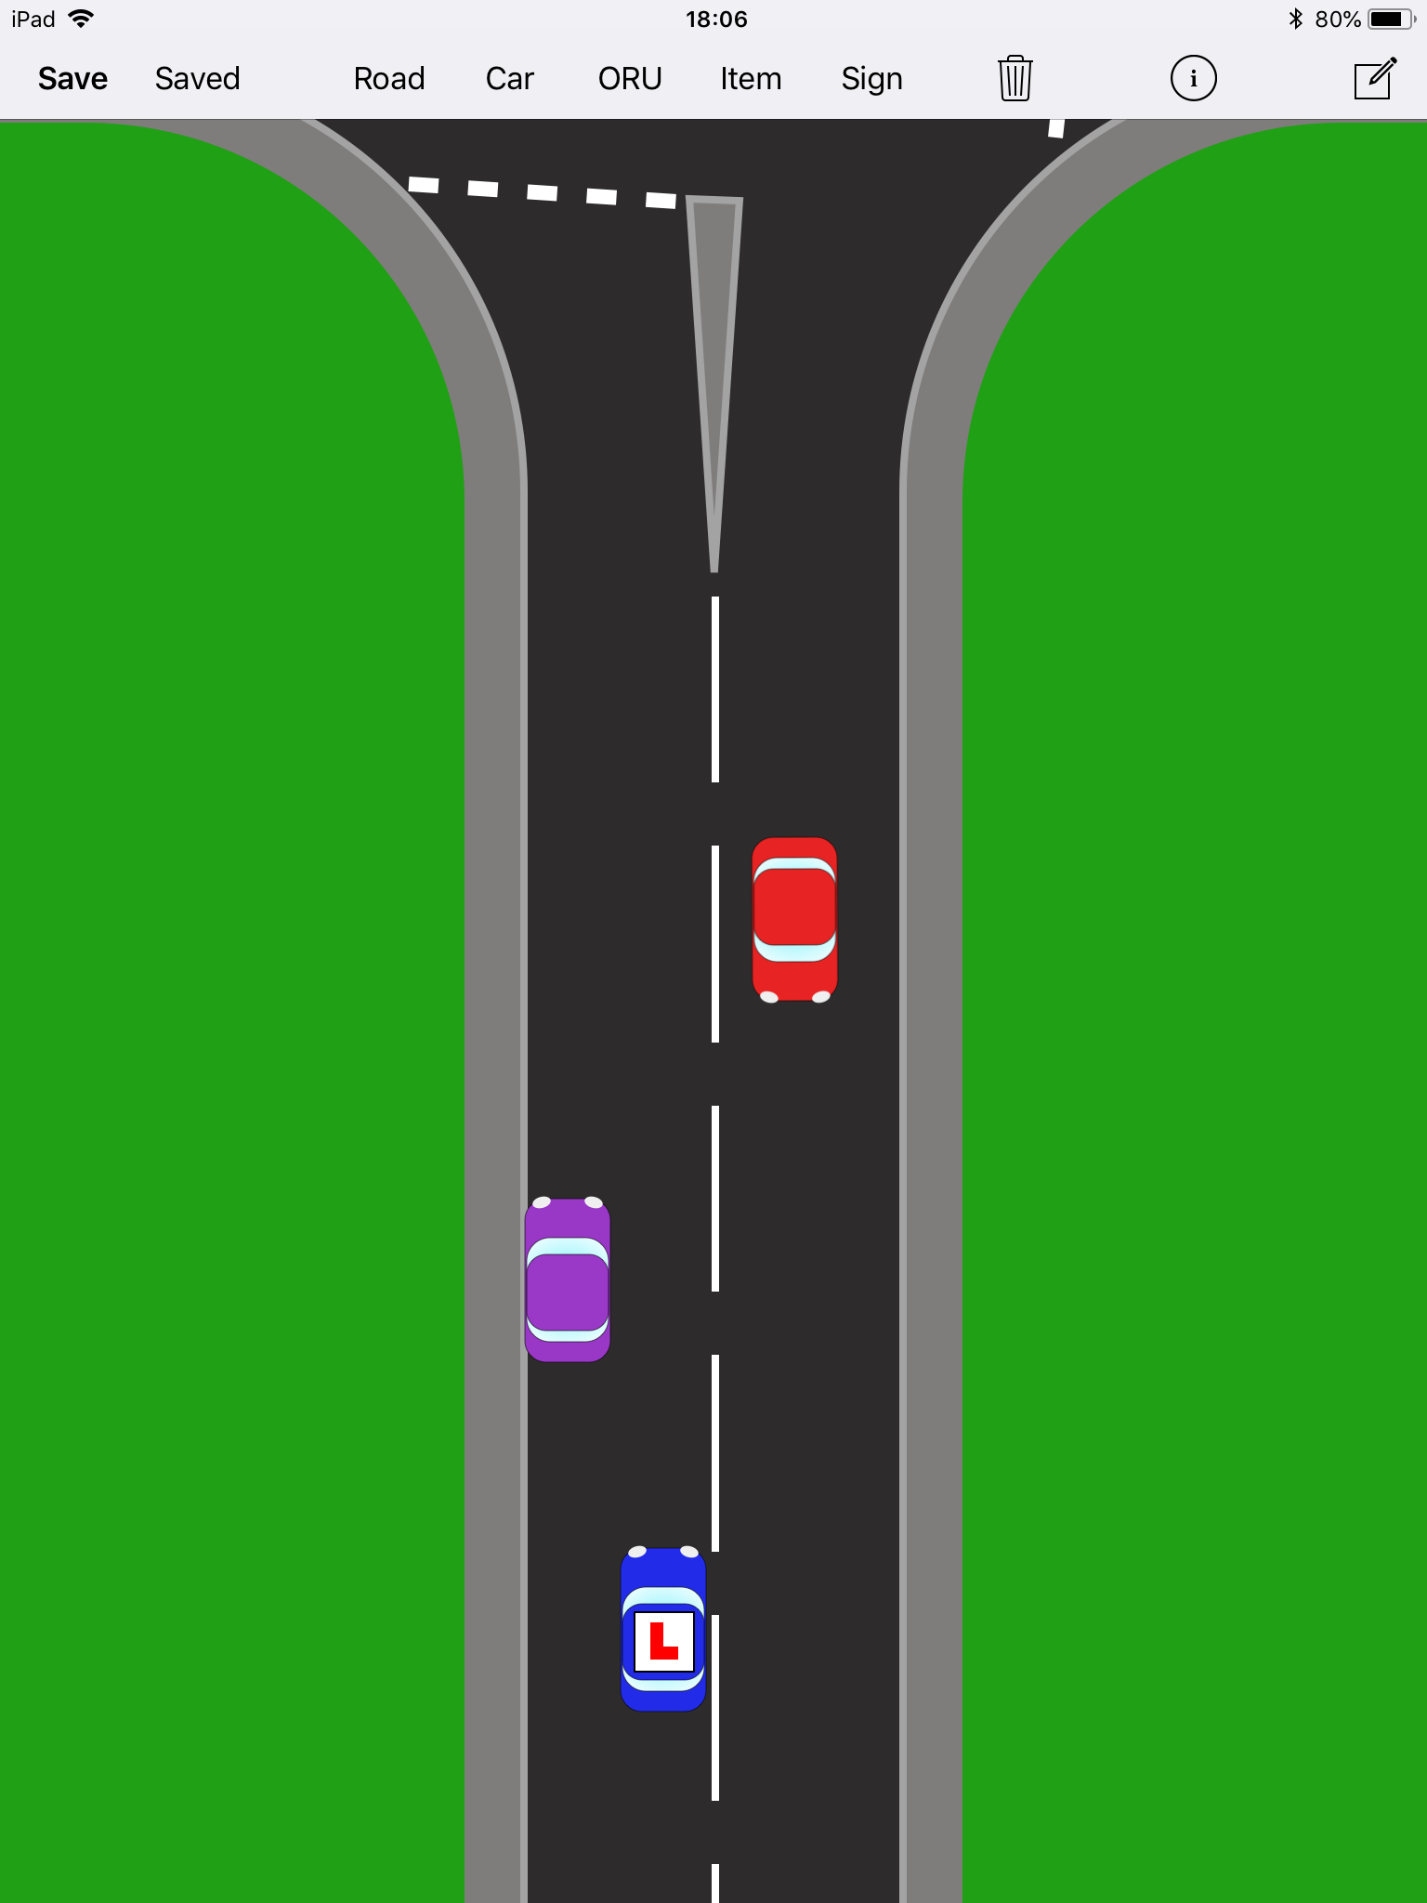

When two cars arrive with equal priority; which goes first?

- Me
- Them

If there is a passing place on the left what would you do?

If there is a passing place on the right what would you do?

Crossroads

If two cars approach cross roads at the same time, on the minor road who has the priority?
- Me
- Him
- Equal

Can you go at the same time?
- Yes
- No
- If both going straight or left

At filter light cross roads if you are turning right on a green light do you wait at the line or wait in the middle?
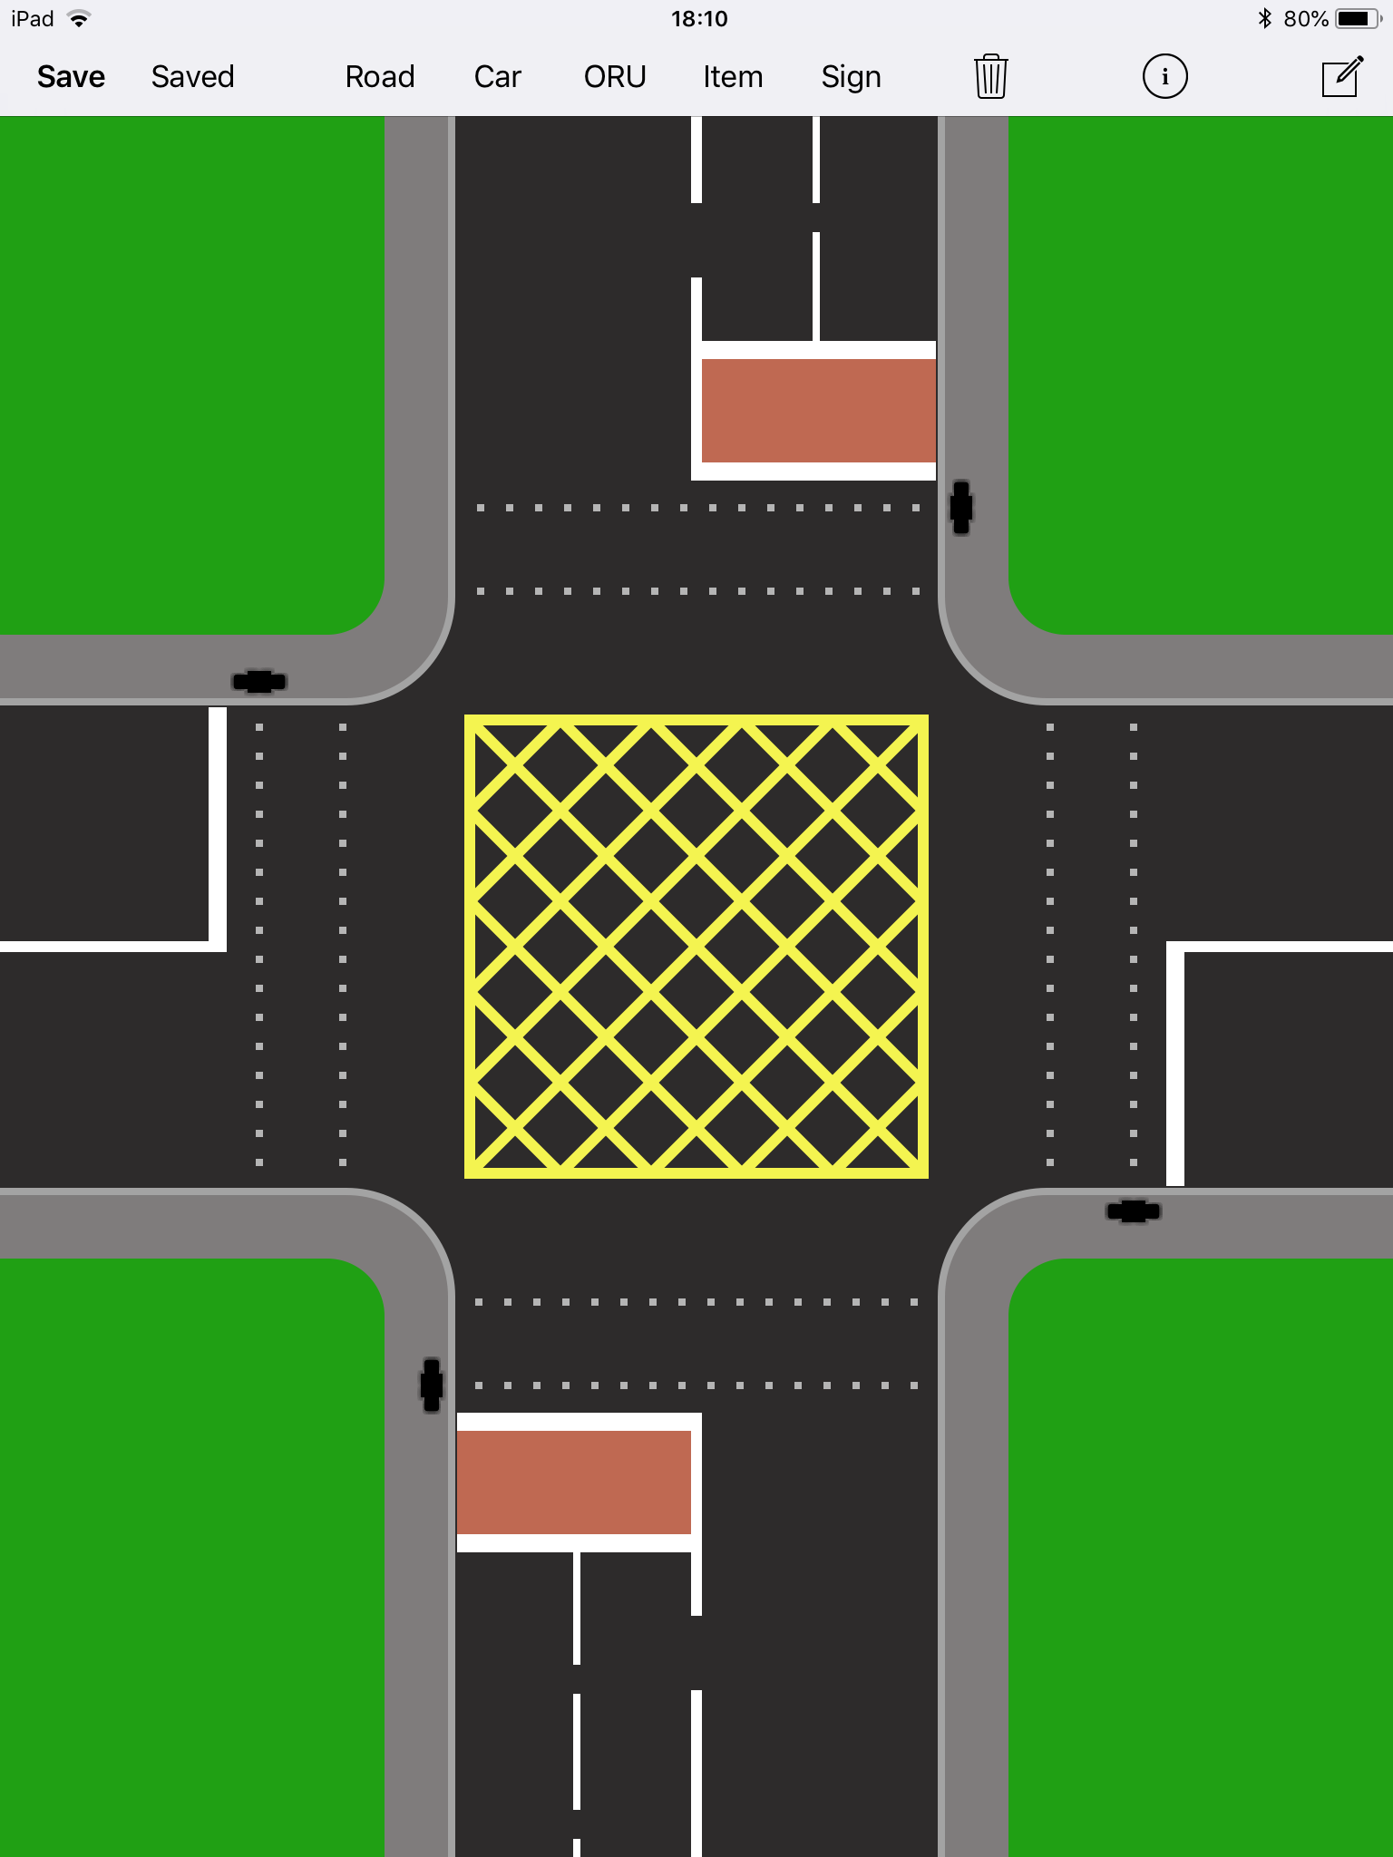

What are you waiting for?

1.
2.
3.
4.

Roundabouts

Why do we have roundabouts?
- The number of cars coming from each way is even
- The number of cars coming from each way is uneven
- To save Electricity from Traffic Lights at every juntion

What does MSPSL stand for?

M
S
P
S
L

Name 4 types of roundabouts?

1.
2.
3.
4.

On a standard roundabout which lane would you usually approach in for turning Left?

Which lane are you usually in for going straight?

Which lane are you usually in for going right?

On a mini roundabout with no road on your immediate right side, who then has the priority?

Imagine this is a Multi-lane Spiral roundabout controlled by traffic lights, and you are round about going right on the 3rd exit firstly from the road on left side. Use this drawing lanes on this drawing.
Then try the other directions

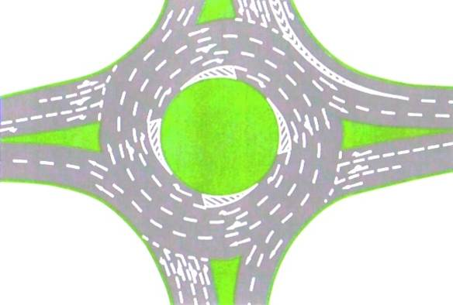

What is a Ring Road?

For a dual roundabout with the major road going around to the right, how many lanes are likely to be allowed to turn right?

What is the different between a lane split and a lane change?

When can you get a lane split on a roundabout?

Hill Starts

How can you make sure that you do not role backwards when you drive off up hill?
- Observe really quickly
- Give the car power before taking the handbrake off
- Take the handbrake off quickly.

Crossing the Path of Traffic

When turning right, how do you know you have enough time to turn without causing the other car to slow?
- If you would feel comfortable walking the whole distance of the road
- If you have 5 metres
- If you have 10 metres

If you were at a standard set of traffic lights turning left, picture, would you look back at the middle of the junction?

When would it be a good idea to look back?

Pedestrian Crossings

What do you find at the side of every Zebra Crossing?

If you cannot see if there are people, what should you do?
- Assume there is a person on the crossing, and reduce your speed accordingly
- Keep your speed up to progress on the road

If you see a green traffic light what should you do?
- Speed up to make the lights
- Assume that light will turn to red

What is the difference between Pedestrian lights and junction lights?
- Cars and Pedestrians cross at junctions
- Only cars turn at junctions

How does this affect the timing of the lights?
- Pedestrians pressing the button only control both lights
- Pedestrian lights only change if a person presses the button

Can you go on an amber flashing light?
- No
- Yes
- If there is no one on the crossing

Lane Changes

Which lane to you normally drive in the UK?
- Left
- Right

What reasons can you be in the other lane?
1.
2.
3.

When Overtaking an cyclist;
When is it unsafe?
- When you do not have a metre
- When you do not have half a metre
- When you do not have two metres

When is it not legal?
- When there is a centre line
- When there is a hazard line
- When there is a solid white line

When is it not necessary?
- When you are not in a hurry
- When you are turning left soon
- When the cyclist is good looking

If you have one of the 3 reason listed above to lane change into the right hand lane; who has priority?

- Me, they should help me
- The cars in the other lane

What Speed do you need to be in order to lane change?
- Faster than the other cars in the lane you are going into
- Slower than the other cars in the lane you are going into
- The same speed as the other cars in the lane you are going into

When you speed is correct can you just go?
- Yes the other cars will help me
- I have to check if the other car is letting me in.

How do you know if another car is helping you?
- The car from your point of view stops get closer, and from their point of view is holding back
- They all will when I signal
- When the other car flashes me with their lights.

What if you are matching speed so well that a car stays on the right all the way up the road?

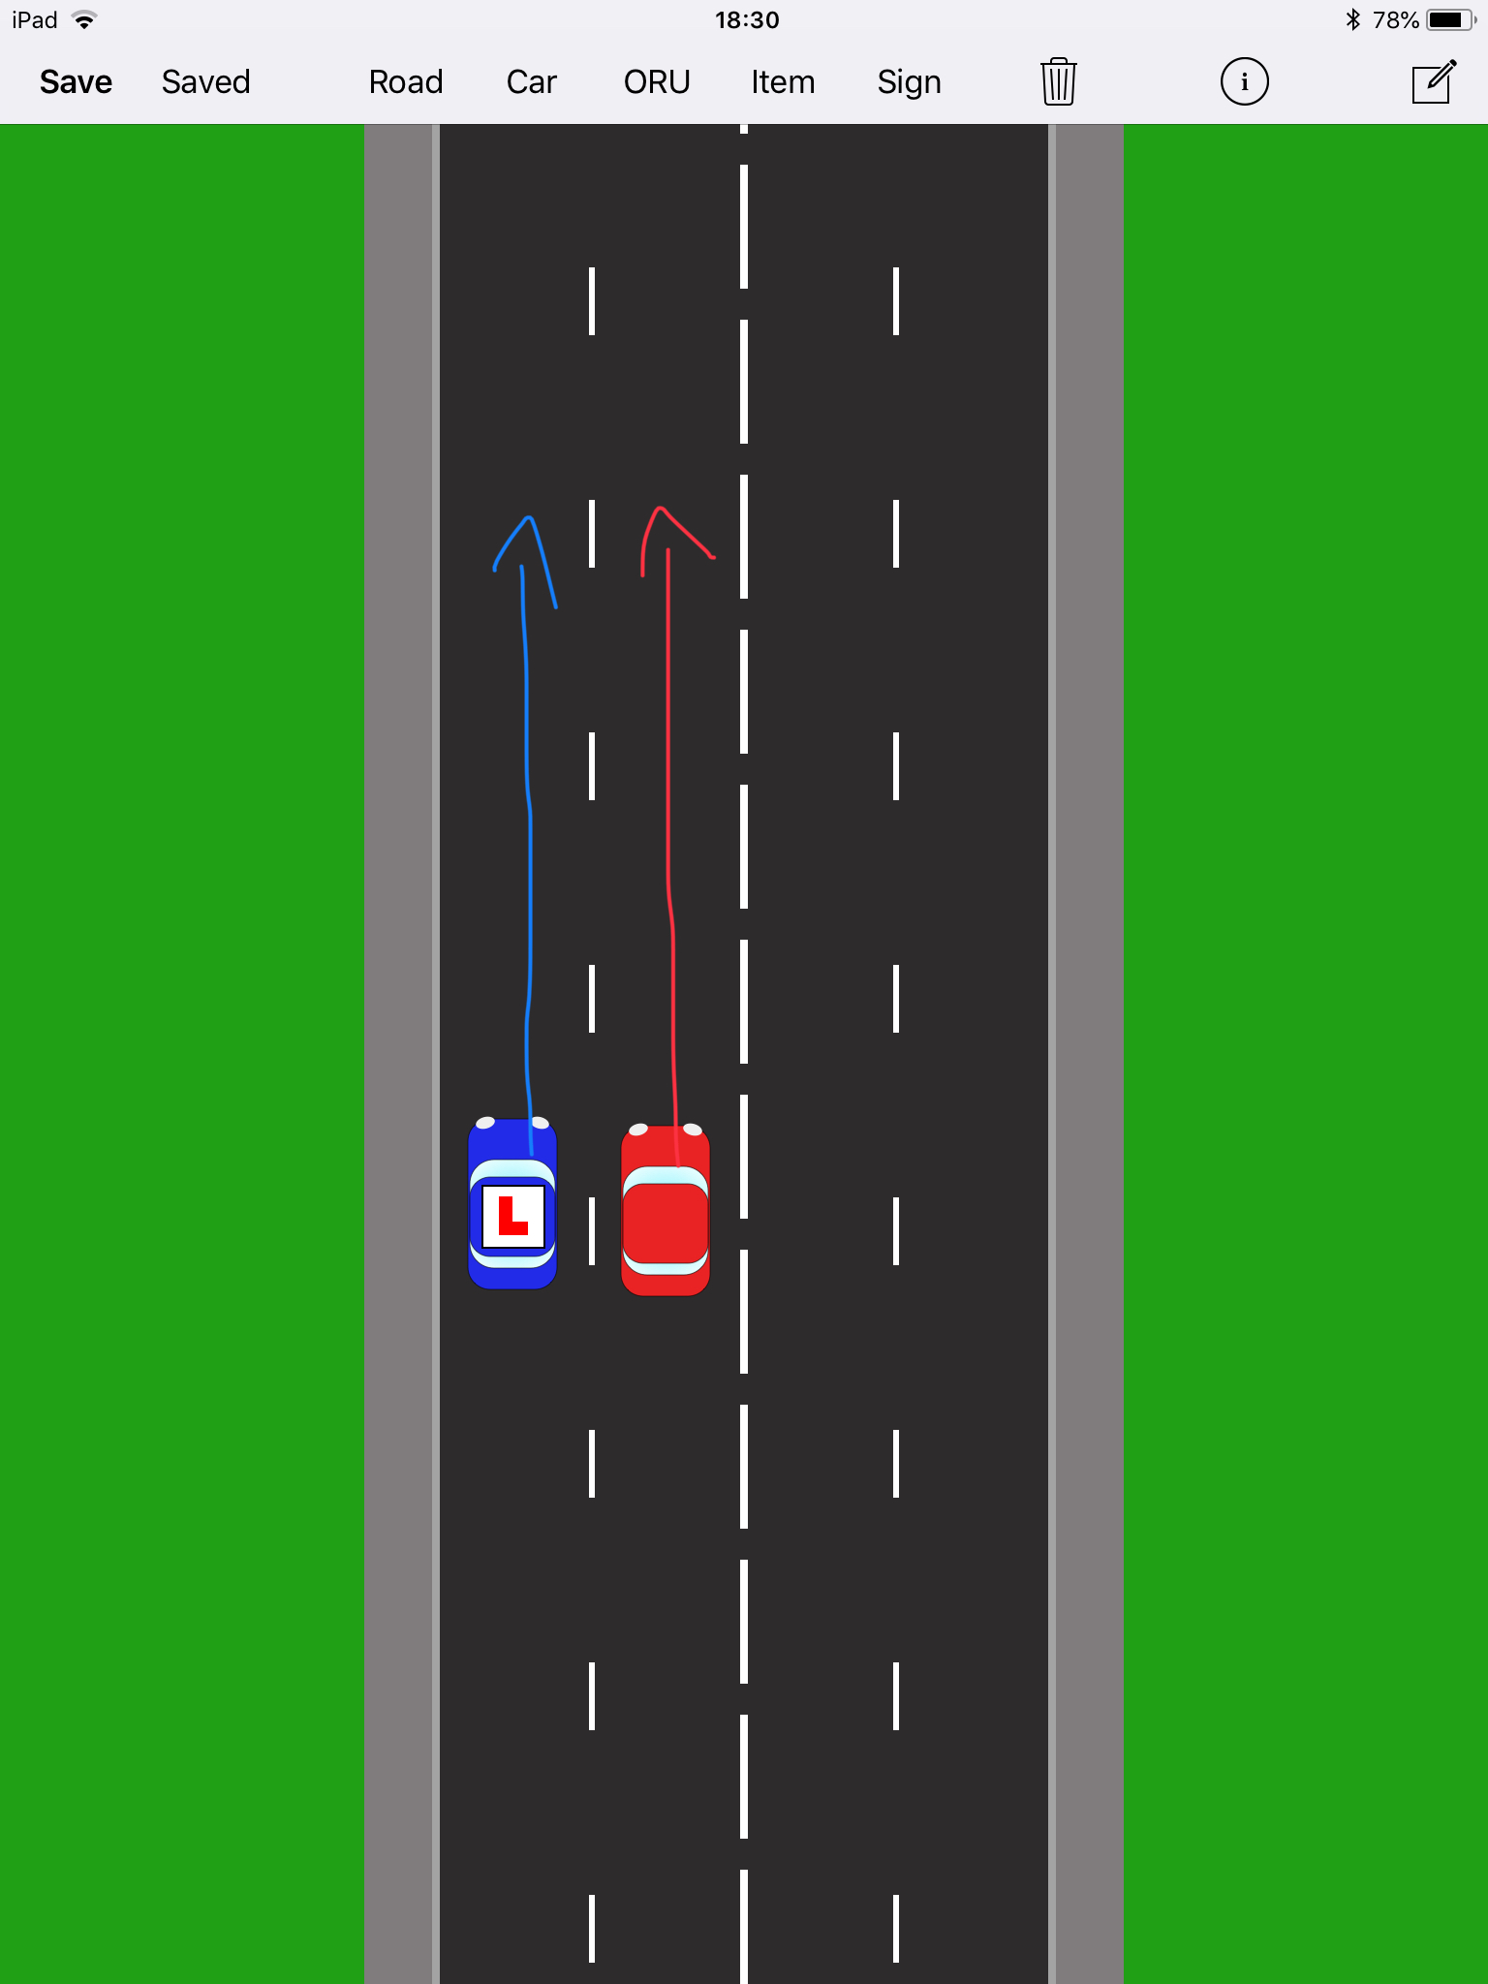

Speed up and go in front of them
- Slow a little and go into the gap behind them
- Move over immediately so that they know to get out of your way

Where should you check before going over into a right hand lane?
- Interior Mirror, right mirror, right shoulder on repeat like a nodding dog
- Just the Interior Mirror
- Just the Right Mirror

